**G. Rupa Manasa**

**Day 2 Assessment**

* First, I have created a database called pet_adoption. In that, animals table and adoption table were created.
* 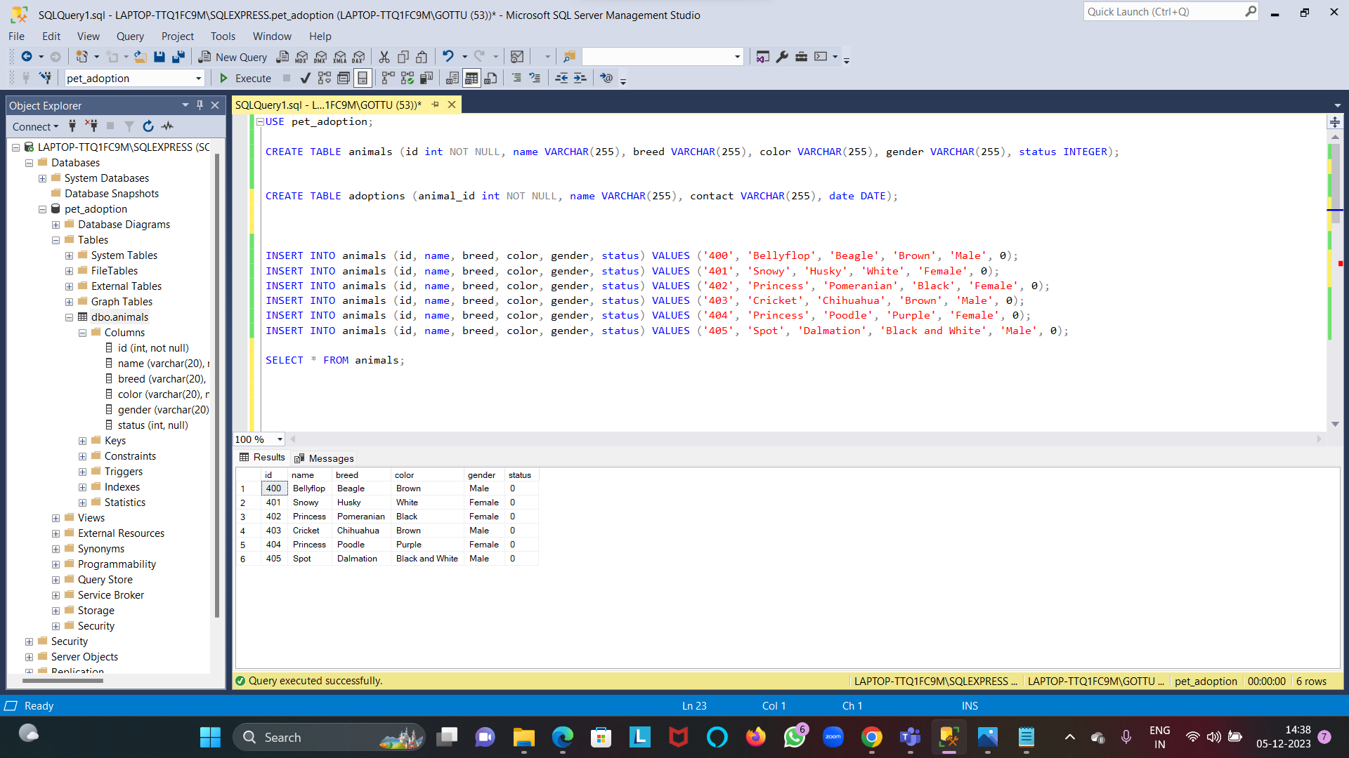The data is inserted into the animals table using INSERT INTO command.
* 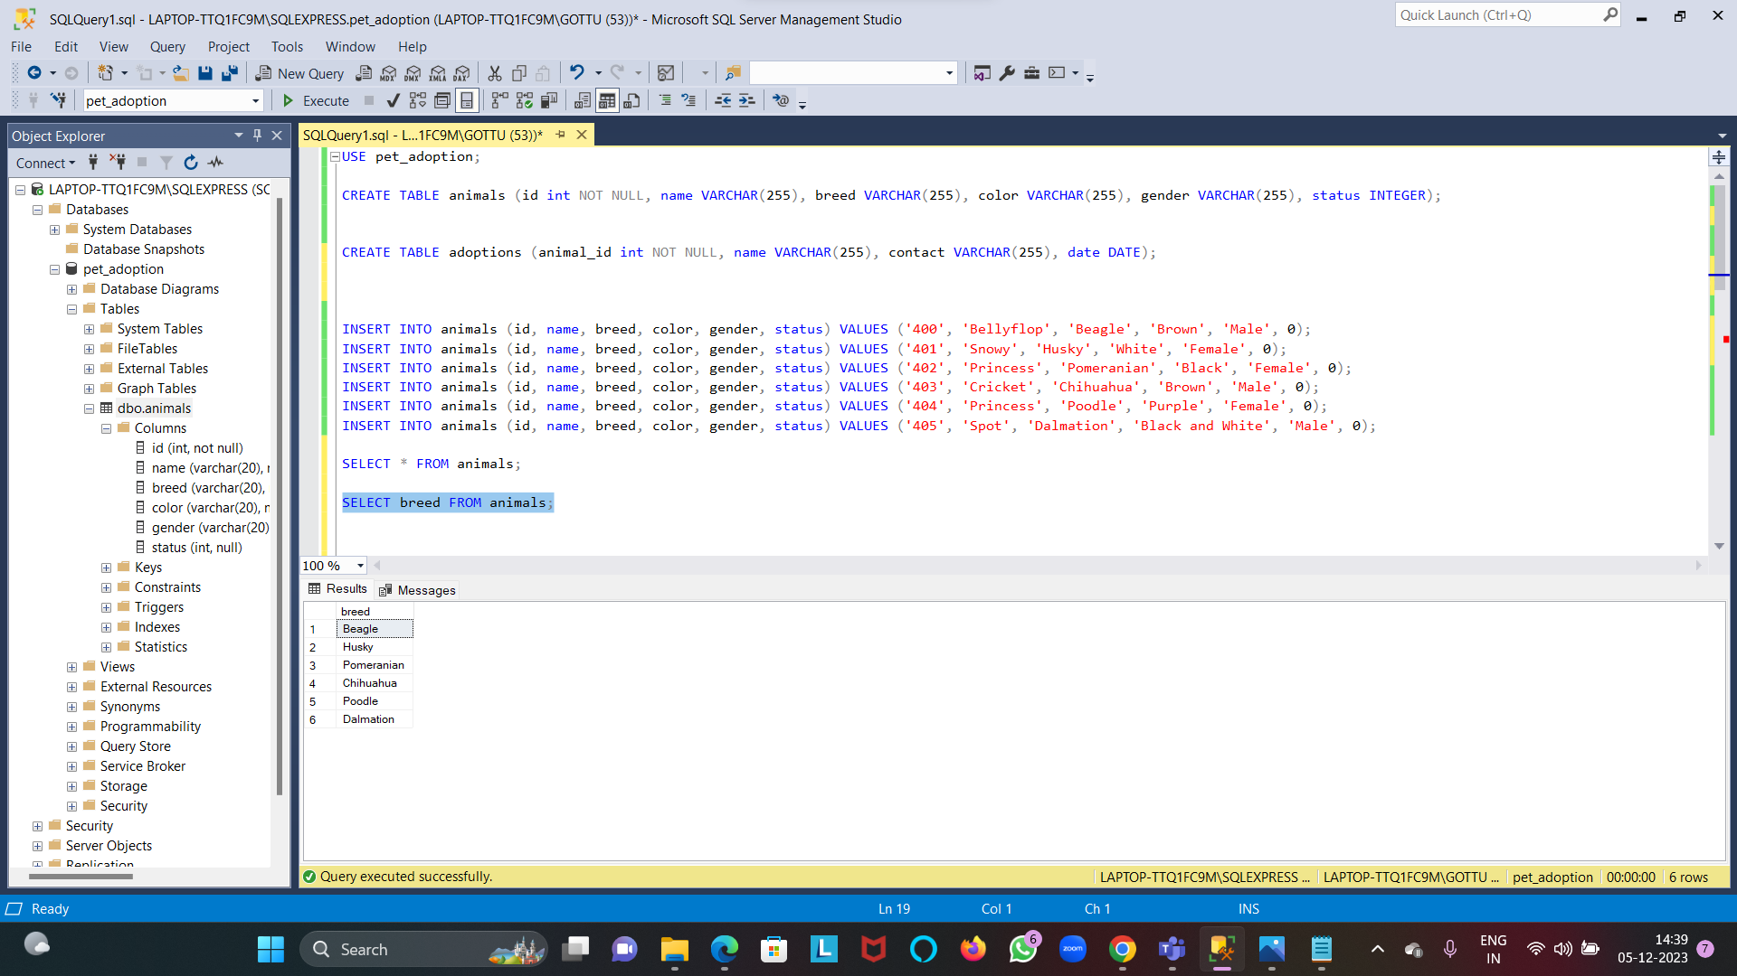To retrieve the data, we use SELECT statement.
* So here the breed column data is retrieved from the animals table.
* 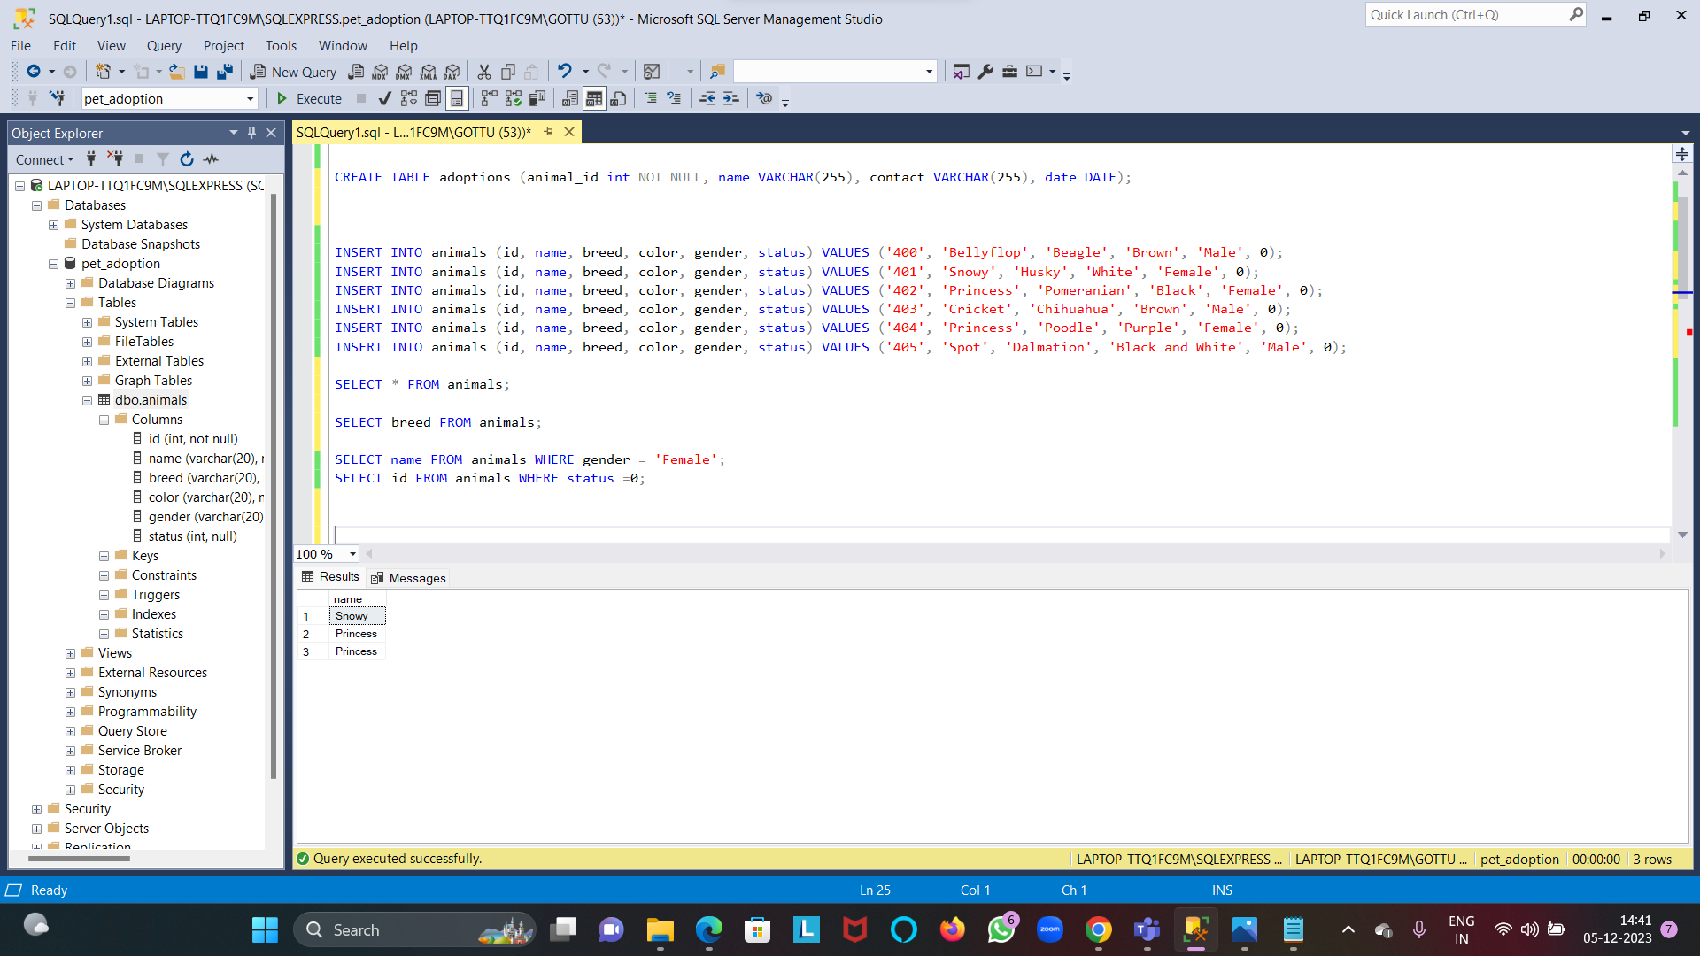Here, WHERE clause is used to provide condition.
* The data is inserted into adoptions table by using INSERT INTO statement.

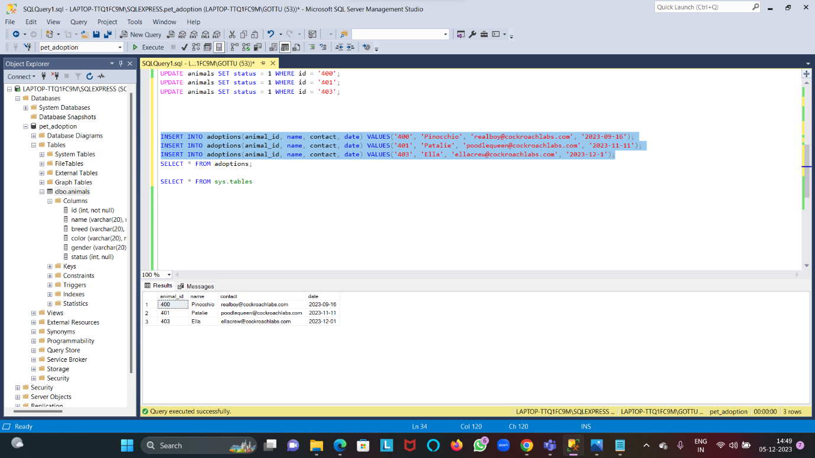

* The status column is updated.

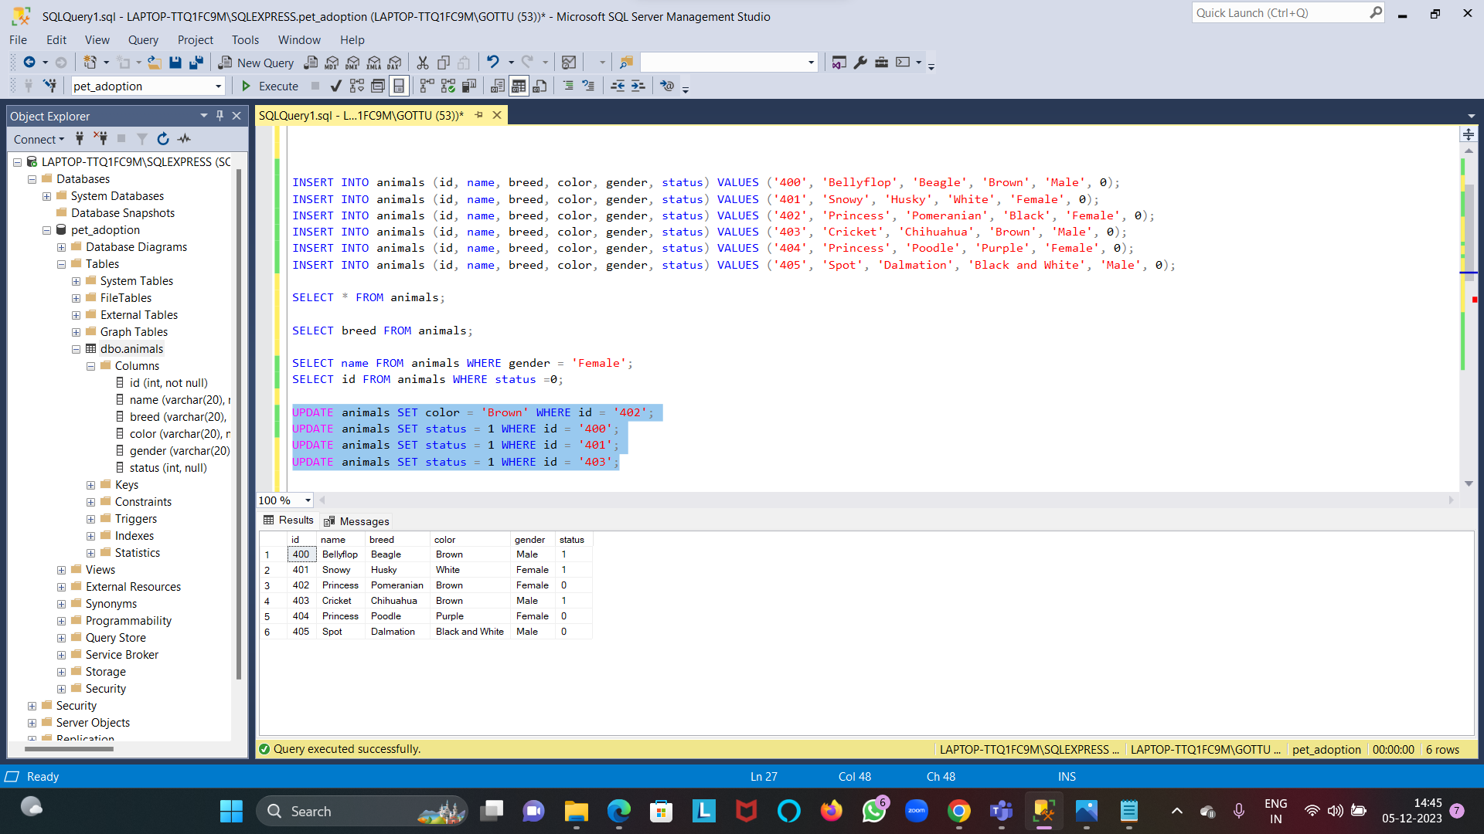

* The ORDER BY statement is used to arrange the data either in ascending order or descending order.

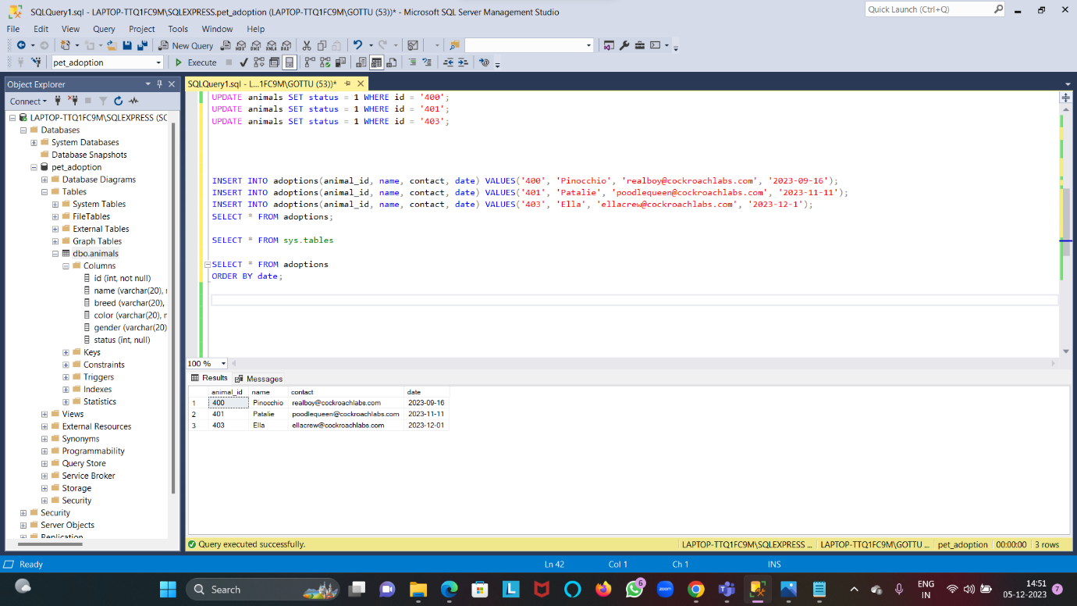

* 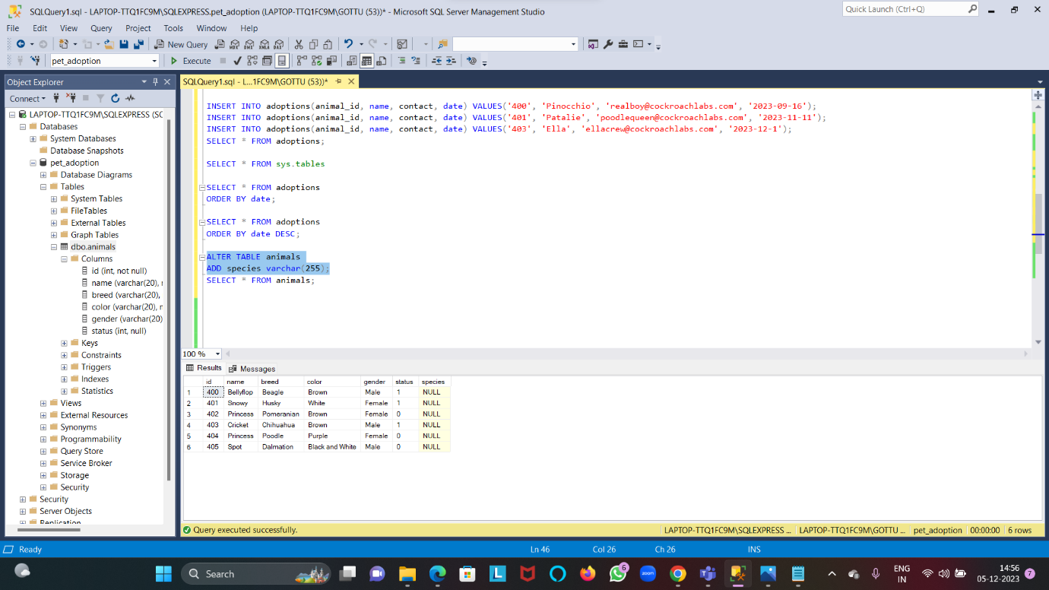Using ALTER TABLE statement, we can add, modify or drop a column.

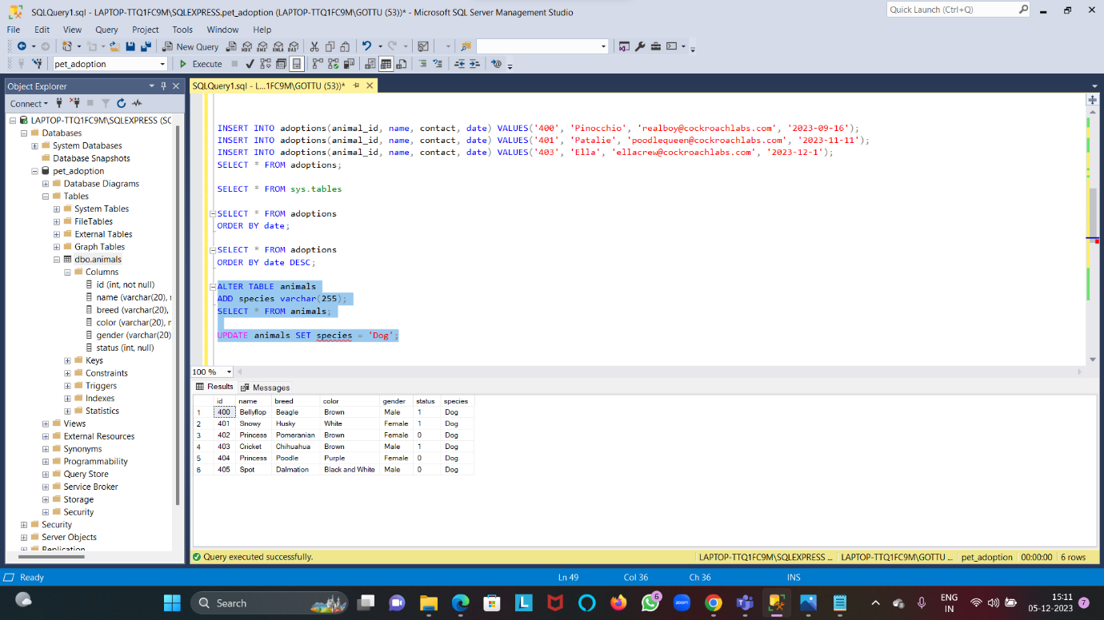

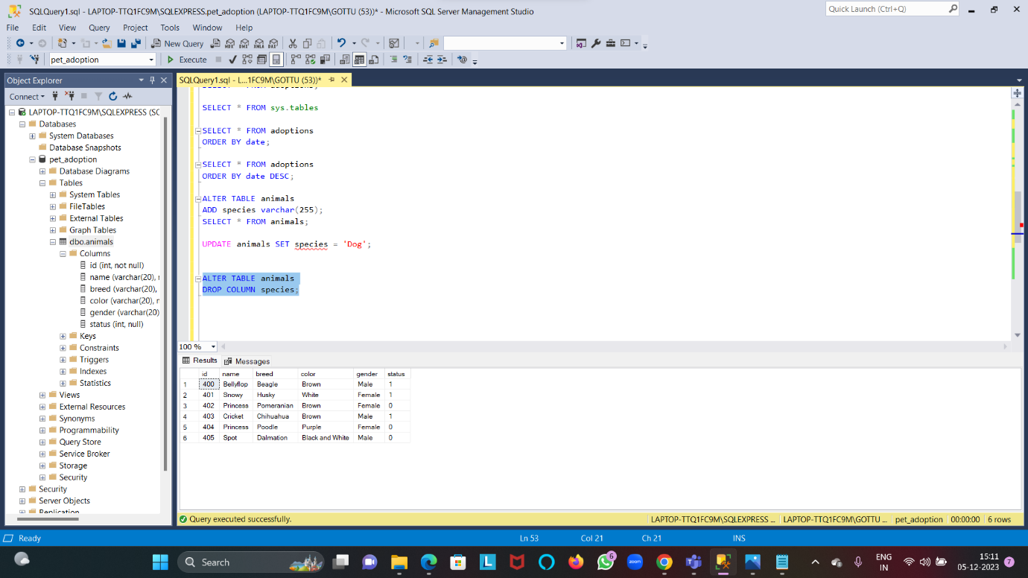

* 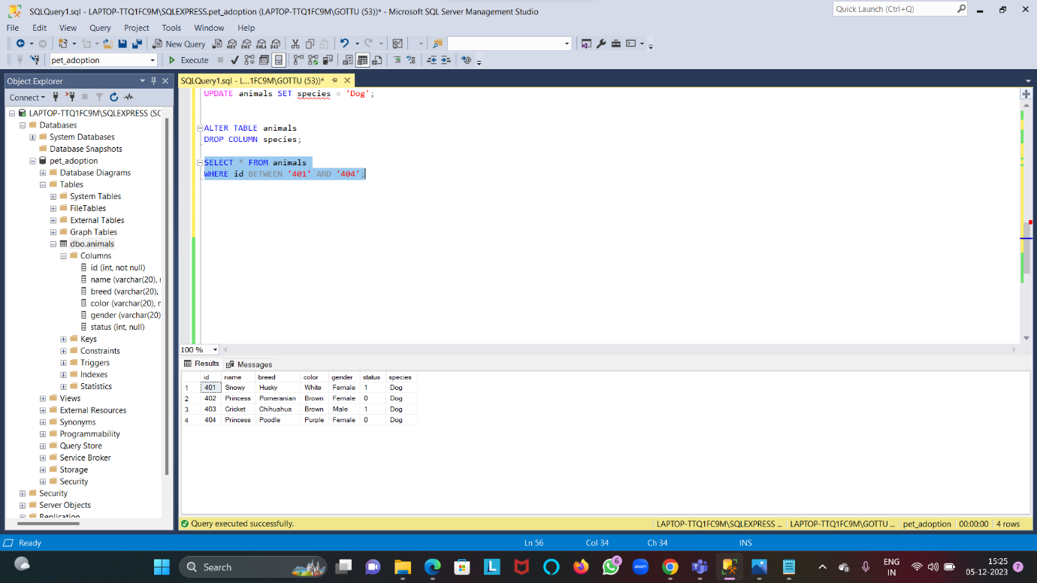WHERE clause with BETWEEN and AND operator.

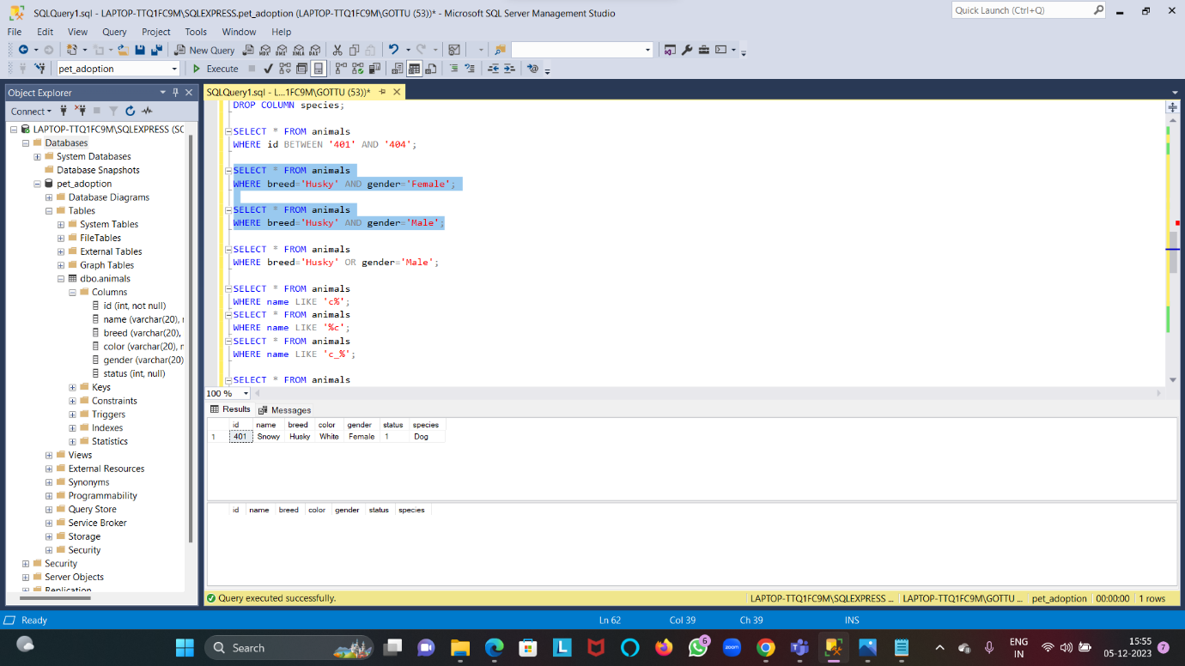

* 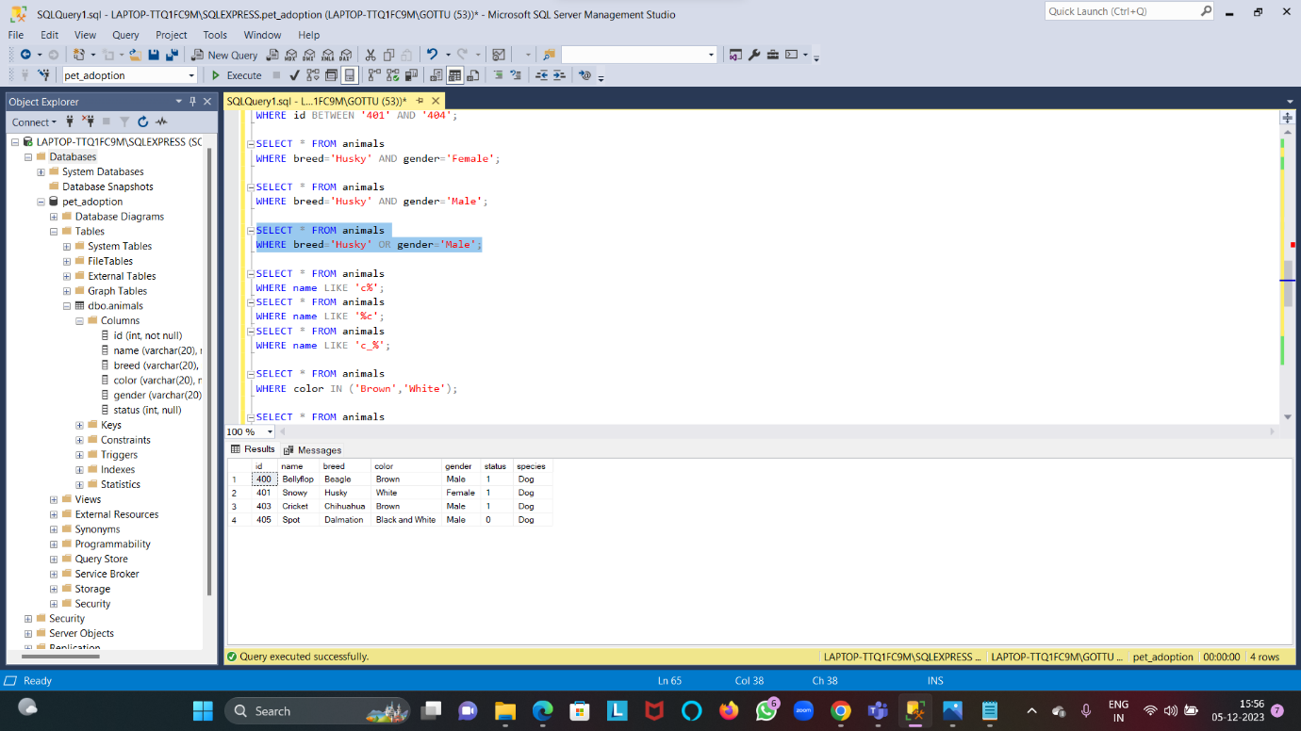WHERE clause with OR OPERATOR

